LAB EXPERIMENTS
EXPERIMENT :1

import pandas as pd

# Create DataFrame
data = {
"DEPARTMENT_ID": [10, 20, 30, 40, 50, 60, 70, 80, 90, 100,
110, 120, 130, 140, 150, 160, 170, 180,
190, 200, 210, 220, 230, 240, 250, 260, 270],
"DEPARTMENT_NAME": [
"Administration", "Marketing", "Purchasing", "Human Resources",
"Shipping", "IT", "Public Relations", "Sales", "Executive",
"Finance", "Accounting", "Treasury", "Corporate Tax",
"Control And Credit", "Shareholder Services", "Benefits",
"Manufacturing", "Construction", "Contracting", "Operations",
"IT Support", "NOC", "IT Helpdesk", "Government Sales",
"Retail Sales", "Recruiting", "Payroll"
],
"MANAGER_ID": [200, 201, 114, 203, 121, 103, 204, 145, 100,
108, 205, 0, 0, 0, 0, 0, 0, 0, 0, 0, 0, 0, 0, 0, 0, 0, 0],
"LOCATION_ID": [1700, 1800, 1700, 2400, 1500, 1400, 2700, 2500, 1700,
1700, 1700, 1700, 1700, 1700, 1700, 1700, 1700, 1700,
1700, 1700, 1700, 1700, 1700, 1700, 1700, 1700, 1700]
}

# Create DataFrame
df = pd.DataFrame(data)

# Display DataFrame
print("Employees Data:")
print(df)

# Select distinct Department IDs
print("\nDistinct Department IDs:")
print(df["DEPARTMENT_ID"].drop_duplicates())



EXPERIMENT 2
import pandas as pd

# Create DataFrame
data = {
"EMPLOYEE_ID": [102, 101, 101, 201, 114, 122, 200, 176, 176, 200],
"START_DATE": ["2001-01-13", "1997-09-21", "2001-10-28", "2004-02-17",
"2006-03-24", "2007-01-01", "1995-09-17", "2006-03-24",
"2007-01-01", "2002-07-01"],
"END_DATE": ["2006-07-24", "2001-10-27", "2005-03-15", "2007-12-19",
"2007-12-31", "2007-12-31", "2001-06-17", "2006-12-31",
"2007-12-31", "2006-12-31"],
"JOB_ID": ["IT_PROG", "AC_ACCOUNT", "AC_MGR", "MK_REP",
"ST_CLERK", "ST_CLERK", "AD_ASST", "SA_REP",
"SA_MAN", "AC_ACCOUNT"],
"DEPARTMENT_ID": [60, 110, 110, 20, 50, 50, 90, 80, 80, 90]
}

df = pd.DataFrame(data)

# Employees with two or more jobs
result = df.groupby("EMPLOYEE_ID").filter(lambda x: len(x) >= 2)

print("Employees who have done two or more jobs:")
print(result["EMPLOYEE_ID"].drop_duplicates())
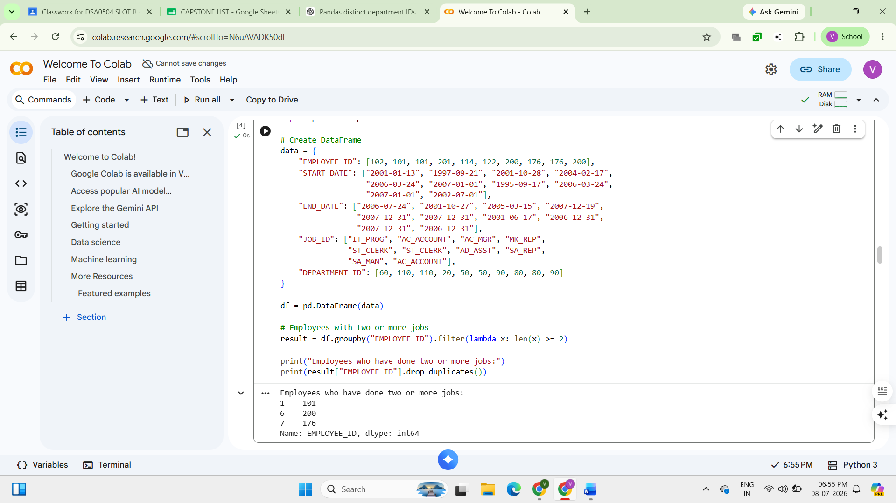

EXPERIMENT 3
import pandas as pd

# Create DataFrame
data = {
"JOB_ID": ["AD_PRES","AD_VP","AD_ASST","FI_MGR","FI_ACCOUNT","AC_MGR",
"AC_ACCOUNT","SA_MAN","SA_REP","PU_MAN","PU_CLERK",
"ST_MAN","ST_CLERK","SH_CLERK","IT_PROG","MK_MAN",
"MK_REP","HR_REP","PR_REP"],

"JOB_TITLE": ["President","Administration Vice President",
"Administration Assistant","Finance Manager",
"Accountant","Accounting Manager","Public Accountant",
"Sales Manager","Sales Representative",
"Purchasing Manager","Purchasing Clerk",
"Stock Manager","Stock Clerk","Shipping Clerk",
"Programmer","Marketing Manager",
"Marketing Representative",
"Human Resources Representative",
"Public Relations Representative"],

"MIN_SALARY": [20080,15000,3000,8200,4200,8200,4200,10000,6000,
8000,2500,5500,2008,2500,4000,9000,4000,4000,4500],

"MAX_SALARY": [40000,30000,6000,16000,9000,16000,9000,20080,12008,
15000,5500,8500,5000,5500,10000,15000,9000,9000,10500]
}

df = pd.DataFrame(data)

# Sort by JOB_TITLE in descending order
result = df.sort_values(by="JOB_TITLE", ascending=False)

print(result)
